

Ziyad Mohammed | 150407

2018/2019

Artificial Intelligence Definition, Ethics and Standards

Electronics and Communications: Law, Standards and Practice | 18ELEC07I

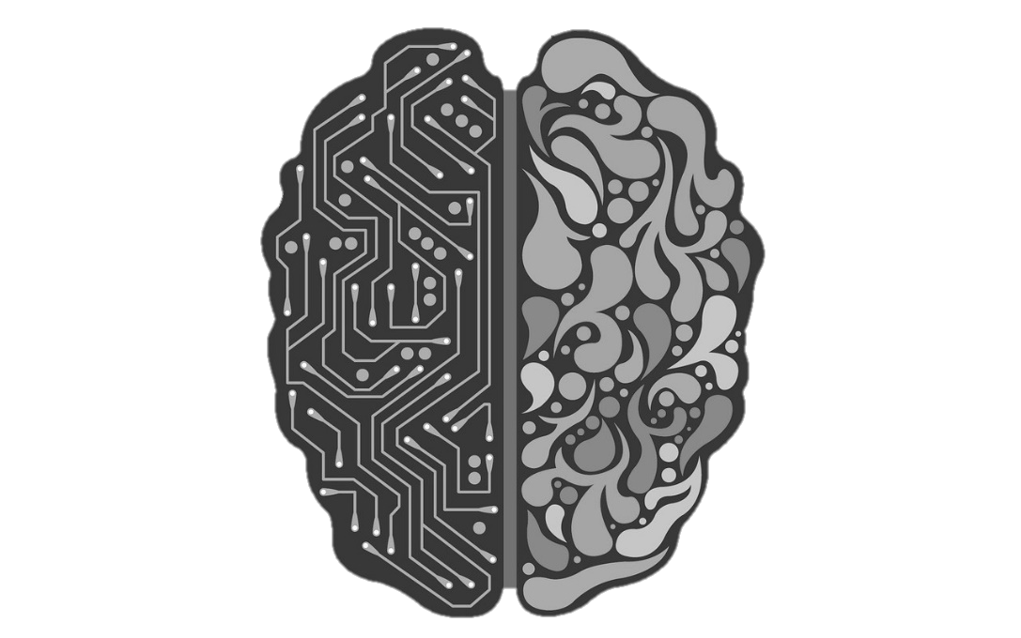

Contents

Abstract 2

Introduction 3

Artifical Intelligence vs Robotics 3

Defining Artificial Intelligence 4

Traits of an AI 4

Types of Ai 4

Type 1 4

Type 2 (based on functionalities) 5

Achieving AI 6

Natural Language Processing (NLP) 7

Vision 7

Autonomous Vehicles 7

Machine learning 7

Ethical AI 8

Standards 8

key areas 8

Foundational standards (Working Group 1) 8

Trustworthiness (Study Group 2) 9

Use cases and applications (Study Group 3) 9

Conclusion 10

References 10

Figure 1: Future of AI 5

Figure 2: AI Branches 6

Figure 3: AI Perception Action Cycle in Autonomous Cars 7

# Abstract

Artificial Intelligence or sometimes called machine intelligence, is intelligence demonstrated by machines, in contrast to the natural intelligence displayed by humans and other animals. Some of the activities that it is designed to do is speech recognition, learning, planning and problem solving. Since Robotics is the field concerned with the connection of perception to action, Artificial Intelligence must have a central role in Robotics if the connection is to be intelligent. Artificial Intelligence addresses the crucial questions of: what knowledge is required in any aspect of thinking; how should that knowledge be represented; and how should that knowledge be used. Robotics challenges Artificial Intelligence by forcing it to deal with real objects in the real world.

# Introduction

Is robotics part of AI? Is AI part of robotics? What is the difference between the two terms? Robotics and artificial intelligence serve different purposes. However, people often get them mixed up. A lot of people wonder if robotics is a subset of artificial intelligence or if they are the same thing.

## Artifical Intelligence vs Robotics

Artificial intelligence (AI) is a branch of computer science. It involves developing computer programs to complete tasks which would otherwise require human intelligence. AI algorithms can tackle learning, perception, problem-solving, language-understanding and/or logical reasoning.

AI is used in many ways within the modern world, from personal assistants to self-driving car. Artificial intelligence (AI) is evolving rapidly. While science fiction every so often portraits AI as robots closely as possible to humans.

However, Robotics is a branch of technology which deals with robots. Robots are programmable machines which are usually able to carry out a series of actions autonomously, or semi-autonomously.

There are three main important factors which constitute a robot:

1. Robots interact with the physical world via sensors and actuators.
2. Robots are programmable.
3. Robots are usually autonomous or semi-autonomous.

Robots are "usually" autonomous because some robots aren't. Telerobots, for example, are entirely controlled by a human operator but telerobotics is still classed as a branch of robotics.

Eventually, artificially intelligent robots are the bridge between robotics and AI. These are robots which are controlled by AI programs.

Many robots are not artificially intelligent. Up until quite recently, all industrial robots could only be programmed to carry out a repetitive series of movements. As we have discussed, repetitive movements do not require artificial intelligence. Non-intelligent robots are quite limited in their functionality. AI algorithms are often necessary to allow the robot to perform more complex tasks.

# Defining Artificial Intelligence

## Traits of an AI

**Capable of predicting and adapting,** AI uses algorithms that discover patterns from huge amounts of information.

**Makes decisions on its own,** AI is capable to augment human intelligence, deliver insights and improve productivity.

**Continuous learning,** AI uses algorithms to construct analytical models. From those algorithms, AI technology will find out how to perform tasks through innumerable rounds of trial and error.

**AI is forward-looking,** AI is a tool that allows people to reconsider how we analyze data and integrate information, and then use these insights to make better decisions.

**AI is capable of motion and perception.**

## Types of Ai

### Type 1

Artificial intelligence today is accurately known as narrow AI (or weak AI), it is non-sentient machine intelligence, typically designed to perform a narrow task (e.g. only facial recognition or only internet searches or only driving a car).

However, the long-term goal of many researchers is to create an artificial general intelligence (AGI or strong AI) which is a machine with the ability to apply intelligence to any problem, rather than just one specific problem, typically meaning "at least as smart as a typical human".

While narrow AI may outperform humans at whatever its specific task is, like playing chess or solving equations, AGI would outperform humans at nearly every cognitive task.

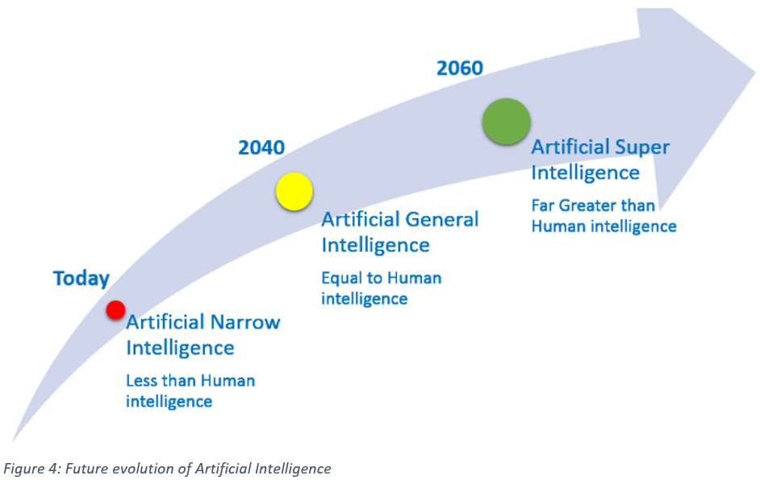The ultimate hypothetical goal is achieving superintelligence (ASI) which is far surpassing that of the brightest and most gifted human minds. Due to recursive self-improvement, superintelligence is expected to be a rapid outcome of creating artificial general intelligence. [1]

[1]

Figure : Future of AI

### Type 2 (based on functionalities)

#### Purely Reactive

Reactive machines are basic in that they do not store ‘memories’ or use past experiences to determine future actions. They simply perceive the world and react to it. IBM’s Deep Blue, which defeated chess grandmaster Kasporov, is a reactive machine that sees the pieces on a chess board and reacts to them. It cannot refer to any of its prior experiences, and cannot improve with practice.

#### Limited Memory

Limited Memory machines can retain data for a short period of time. While they can use this data for a specific period of time, they cannot add it to a library of their experiences. Many self-driving cars use Limited Memory technology: they store data such as the recent speed of nearby cars, the distance of such cars, the speed limit, and other information that can help them navigate roads.

#### Theory of Mind

Psychology tells us that people have thoughts, emotions, memories, and mental models that drive their behaviour. Theory of Mind researchers hope to build computers that imitate our mental models, by forming representations about the world, and about other agents and entities in it. One goal of these researchers is to build computers that relate to humans and perceive human intelligence and how people’s emotions are impacted by events and the environment. While plenty of computers use models, a computer with a ‘mind’ does not yet exist. Examples like C-3PO R2-D2 from Star Wars Universe and Sonny in the 2004 film *I, Robot*

#### Self-Awareness

Self-aware machines are the stuff of science fiction, though many AI enthusiasts believe them to be the ultimate goal of AI development. Even if a machine can operate as a person does, for example by preserving itself, predicting its own needs and demands, and relating to others as an equal, the question of whether a machine can become truly self-aware, or ‘conscious’, is best left for philosophers. Examples like Eva in the 2015 movie *Ex Machina* and Synths in the 2015 TV series *Humans*.

# Achieving AI

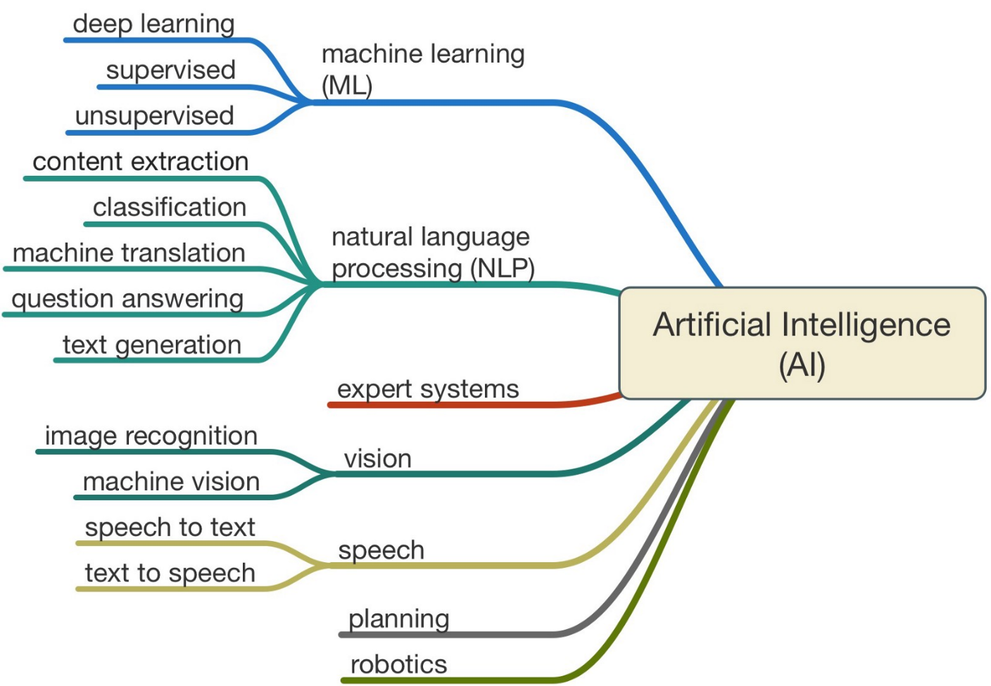There are many ways of achieving AI some of them are as follows:

[5]

Figure : AI Branches

But we will be discussing the most important among them.

## Natural Language Processing (NLP)

Natural language processing helps computers communicate with people in their very own language and scales other language-related tasks. For example, NLP makes it possible for computers to read text, hear speech, interpret it, measure thoughts and emotions, and determine which parts are important. Today's machines can analyze more language-based information than humans without exhaustion and in a continuous, unbiased way.

## Vision

In recent years, the cost of acquiring and identifying large data sets has gone down due to advances in IIoT, making machine learning more accessible for inspection applications then ever before. The other main way AI is used in vision systems is to improve recognition applications continuously.

## Autonomous Vehicles

Autonomous cars generate data from their surroundings and feeds it into the intelligent agent, which in turn takes decisions and allow an autonomous vehicle to conduct specific activities in almost the same environment, a repetitive loop is established called a perception activity cycle. The figure below shows the autonomous vehicle data flow: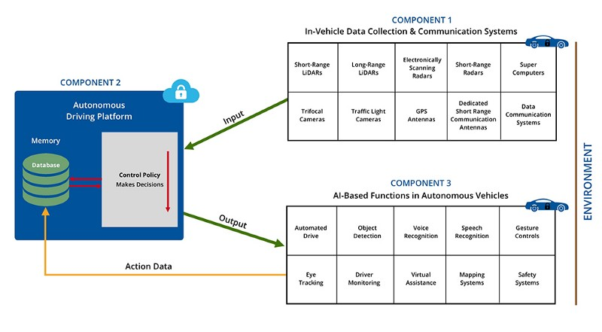

Figure : AI Perception Action Cycle in Autonomous Cars

[2]

## Machine learning

Machine Learning (ML) is an algorithm category that enables software applications to predict responses more accurately and specifically without explicitly programming them. Machine learning is primarily focused on the development of algorithms which are capable of receiving input data as well as using statistical analysis to predict an output while updating outputs with new data.

# Ethical AI

[3]

Trustworthy AI should comply with all applicable legislation and regulations and a set of requirements; specific lists of evaluations are intended to help verify the application of each of the main requirements.

Robust and Safety: Dependable AI requires safe, reliable and robust algorithms that address mistakes or inconsistencies throughout all the life cycle phases of the AI systems.

Privacy and data governance: Citizens should have full control over their own personal data, whereas their data should not be used for harm or discrimination against them.

Transparency: Tractability should be guaranteed for AI systems.

Diversity, non - discrimination and fairness: AI systems should consider and guarantee accessibility and the full range of human capabilities, skills and requirements.

Societal and environmental well-being: AI systems should be used to promote positive social change and improve environmental sustainability.

Accountability: Mechanisms should be placed to ensure accountability and responsibility for AI systems and their products.

# Standards

[4]

In 2017, International Electrotechnical Commission (IEC) and International Organization for Standardization (ISO) became the first international standards development organizations (SDOs) to set up a joint committee (ISO/IEC JTC 1/SC 42) which will carry out standardization activities for artificial intelligence.

Following the opening meeting in Beijing this April, Wael William Diab, Chairman of SC 42. In the area of information and communication technologies (ICT), Diab is a business and technology strategist with 875 patents. At present he is Huawei's senior director.

## key areas

### Foundational standards (Working Group 1)

* Framework for artificial intelligence systems using machine learning ISO/IEC AWI 23053.
* Consider the diverse technologies used by the AI systems, including their properties and characteristics (ML algorithms, reasoning, etc.).
* Consider current specialized AI (NLP or computer vision) systems to understand, characterize and comprehend their underlying computational approaches, architectures and features.
* Investigate industries, processes and methods for AI systems application.
* Develop proposals for new work items and recommend placement where appropriate.

### Trustworthiness (Study Group 2)

* Investigate approaches to building confidence in AI systems through transparency, authentication, expandability and controllability.
* Look at engineering faults and evaluate with mitigation techniques and strategies typically associated threats and risks for AI systems.
* Take account of approaches to the strength, adaptability, reliability, accuracy, safety and privacy of AI systems.
* Consider the types of bias sources in AI systems to be minimized, such as statistical biases in AI systems and the decision-making process supported by AI.
* Develop proposals for new items of work and recommend placement where appropriate.

### Use cases and applications (Study Group 3)

* Identify different areas of AI applications and their various context (fin-tech, health, smart home, autonomous car, social networks and embedded systems).
* Collect representative use cases.
* To describe and use applications using the ISO / IEC AWI22989 and ISO / IEC AWI 23053 terminology and concepts, extending the terms as required.
* Develop suggestions and recommend placement as appropriate for new items of work.

# Conclusion

There is a difference between AI and Robotics and there is also a common area which is artificially intelligent robots. There is are a lot of ways of achieving AI which is why some guidelines should be put. Ethical constraints to comply with all the regulations. Standards are also put to govern the future of AI.

# References

|  |  |
| --- | --- |
| [1] | R. Saracco, "Computers keep getting better … than us," *IEEE Future Directions,* 2018. |
| [2] | S. Gadam, "Artificial Intelligence and Autonomous Vehicles," 19 April 2018. [Online]. Available: https://medium.com/datadriveninvestor/artificial-intelligence-and-autonomous-vehicles-ae877feb6cd2. |
| [3] | European Commission, "Ethics guidelines for trustworthy AI," European Commission, 2019. |
| [4] | A. Price, "First International Standards committee for entire AI ecosystem," *e-tech,* no. 03/2018, 2018. |
| [5] | C. Kumar, "Artificial Intelligence: Definition, Types, Examples, Technologies," 31 August 2018. [Online]. Available: https://medium.com/@chethankumargn/artificial-intelligence-definition-types-examples-technologies-962ea75c7b9b. |